 **Introduction to DevOps**

**BCS/BS 6A**

Lab: 10

# GROUP MEMBERS:

MUHAMMAD SHAYAN SHAHID (2212325)

MUHAMMAD ASHAD BAIG (2212115)

Task 1: Create a Policy assignment

In this task, we will configure the allowed location policy and assign it to our subscription.

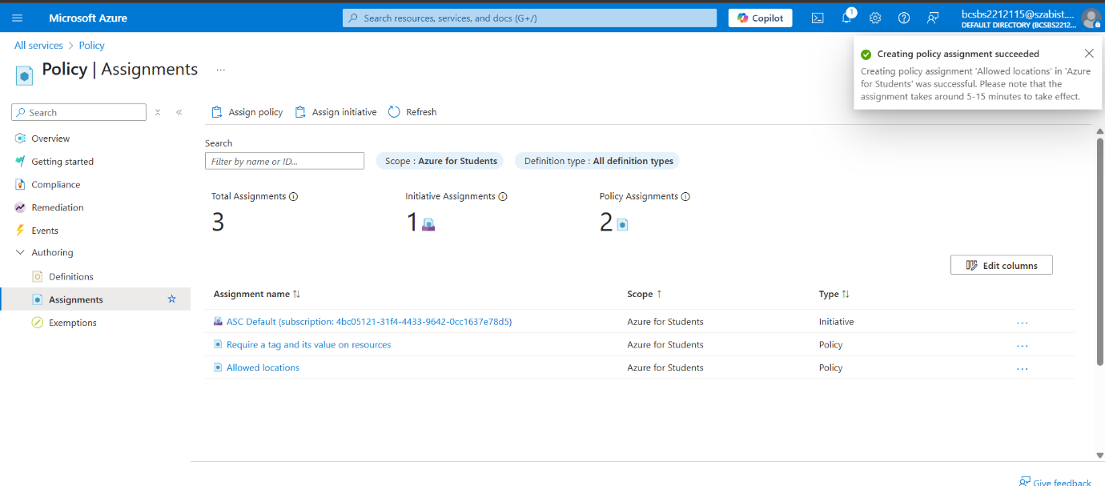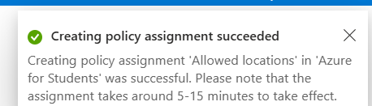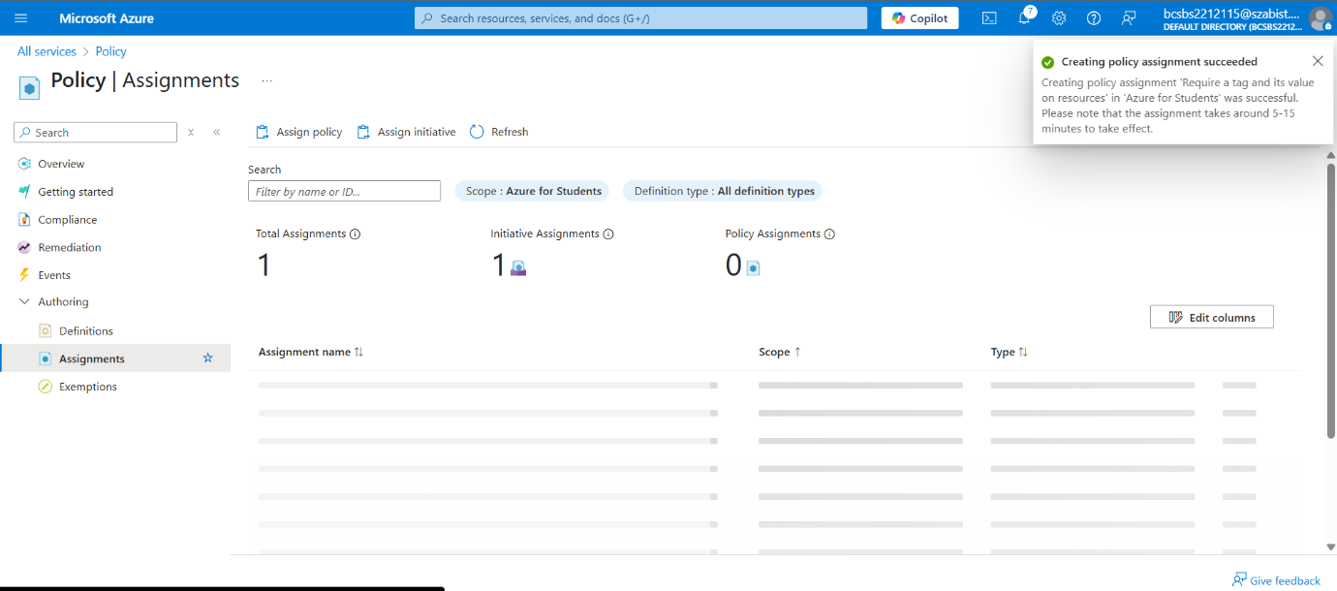

Task 2: Test Allowed location policy

In this task, we will test the Allowed location policy.

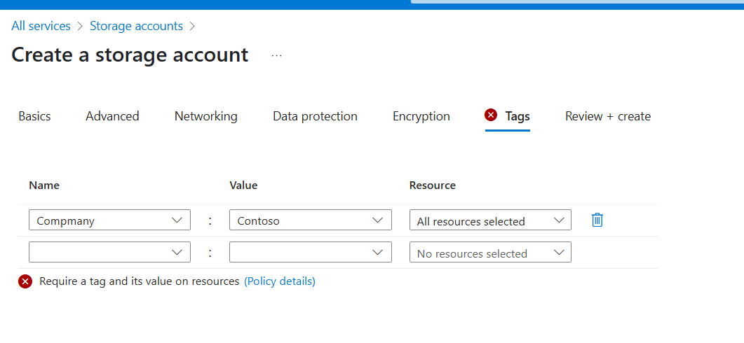

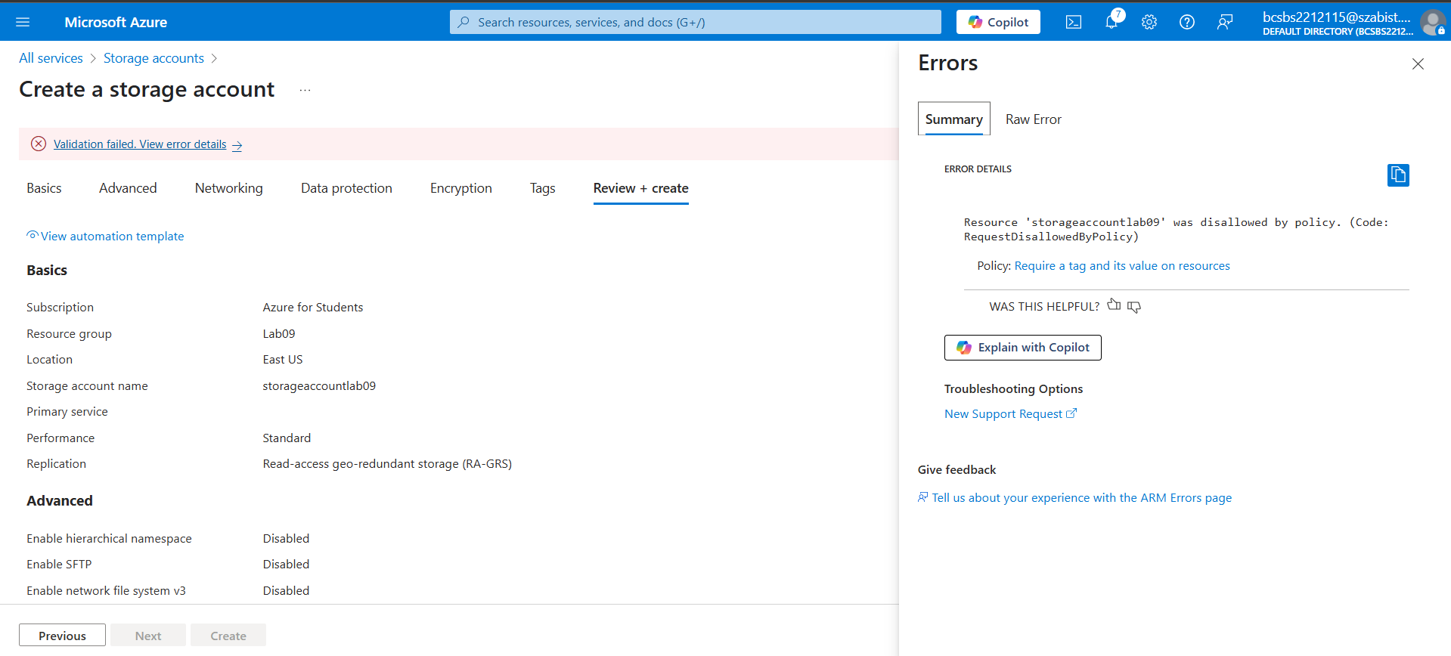

Task 3: Delete the policy assignment

In this task, we will remove the Allowed location policy assignment and test.

We will delete the policy assignment to ensure we are not blocked on any future work we wish to do.

